Inventory Management System (IMS)
IT Scoping & Architecture Document
1. Executive Summary
The Inventory Management System (IMS) is a strategic, centrally governed decision support platform designed to improve stock availability, optimise working capital, and strengthen inventory planning governance across the network. IMS replaces fragmented, manual, and site-specific inventory logic with a single, auditable, and rules driven engine that delivers consistent, explainable, and repeatable inventory decisions.
IMS supports inventory profiling, pullback, replenishment advisory, and branch levelling by consuming master, transactional, and inventory data from ERP and associated operational systems. Deterministic business rules are applied to generate inventory, replenishment, and balancing proposals, while all financial and transactional execution remains fully controlled within core ERP and downstream execution platforms.
As part of the replenishment process, IMS generates advisory output files based on the applied rules and parameters. These files are passed to MAM, which is responsible for creating purchase orders and routing them through the appropriate consolidation or direct to NDC flows. MAM subsequently generates pick notes, RTS notes, and relevant purchase orders (e.g. on 3470 or 192). Confirmation flows returning via SS / Midpoint are linked back into SLIM to ensure on order quantities are accurately represented within planning and inventory positions.
Phase 1 establishes the core IMS capability and decision logic. During this phase, execution of downstream processes may be manually initiated to control risk and validate outcomes. Subsequent phases deliver full end-to-end integration, progressively removing manual intervention and enabling a more automated, scalable, and tightly governed inventory planning and replenishment process.
Business Objectives & Value
- Improve service levels and availability through consistent inventory logic.
- Reduce excess and obsolescence via better profiling and balancing.
- Establish full transparency and auditability of inventory decisions.
- Enable future automation and intelligent optimisation.
2. Scope & Delivery Phases
  - Scope
The following components and capabilities are in scope:
- SQL Server database schemas:
    - Consolidated tables
    - Summary tables
    - Admin, parameter, and audit tables
- Stored procedures implementing:
    - Profiling logic (Enhance the current STARS Logic)
    - Pullback logic
    - Replenishment logic
    - Branch levelling logic
- ASP.NET Core Web API / application layer
- Browser based frontend application
- Batch scheduling and orchestration
- Role based access control
- Full audit logging of parameters and executions

  - Delivery Phases
- Phase 1 – Core Inventory Decision Engine: Phase 1 delivers the foundational IMS platform and replaces existing STARS logic.
  - Central inventory profiling, pullback, replenishment, and branch levelling logic
  - Parameter- and rule-driven execution with full audit trails
  - Planner-facing web interface for configuration, execution, and review
  - Advisory outputs only; no automated transactional posting
Business Outcome:
  - Standardised decision-making
  - Increased planner trust and visibility
  - Immediate governance and audit compliance

- Phase 2 – Integration, Automation & Reporting: Phase 2 focuses on efficiency, integration, and performance insight.
  - Integration with MAM+ and replenishment platforms
  - Automated generation of advisory replenishment files
  - Integrating Seasonality
  - Extended data inputs (Branch ABC, Car Parc, PIM / Edge attributes)
  - Inter-branch pooling and balancing
  - Enterprise reporting and KPIs
Business Outcome:
  - Reduced manual effort
  - Increased automation

- Phase 3 – Pricing & Intelligent Optimisation: Phase 3 introduces advanced optimisation capabilities.
  - Pricing
  - AI / Inotropy feedback loops
  - Scenario modelling and continuous improvement
Business Outcome:
  - Margin-aligned inventory decisions
  - Continuous demand and stock optimisation

Scope
The following components and capabilities are in scope:
- SQL Server database schemas:
  - Consolidated tables
  - Summary tables
  - Admin, parameter, and audit tables
- Stored procedures implementing:
  - Profiling logic (Enhance the current STARS Logic)
  - Pullback logic
  - Replenishment logic
  - Branch levelling logic
- ASP.NET Core Web API / application layer
- Browser based frontend application
- Batch scheduling and orchestration
- Role based access control
- Full audit logging of parameters and executions

3. Logical Architecture
IMS follows a layered logical architecture:
- Source systems provide data inputs only
- Data is standardised and stored in consolidated tables
- Business ready datasets are exposed via summary tables
- All inventory logic is executed via stored procedures
- The front-end consumes results exclusively through the application layer
No business logic is embedded in the user interface. All logic is parameter driven, version controlled, and auditable.

4. Physical Architecture
The physical architecture defines the deployment and runtime model of the IMS solution and enforces strict separation of responsibilities across tiers.
4.1 Infrastructure Specification (Production)
Deployment Model: Single physical or virtual server
Recommended Capacity:
- CPU: 24–32 vCPUs
- Memory: 192–256 GB RAM
- Storage: 2 - 4 TB High-performance SSD with segregated volumes (data, logs, TempDB, backups)
- Platform: Windows Server with Microsoft SQL Server
Designed to support overnight batch processing and concurrent business hours usage.
4.1 Architecture Overview
IMS is deployed across four core components:
- Database Server
- Application Server
- Scheduler
- Frontend
Direct front-end access to the database is not permitted.
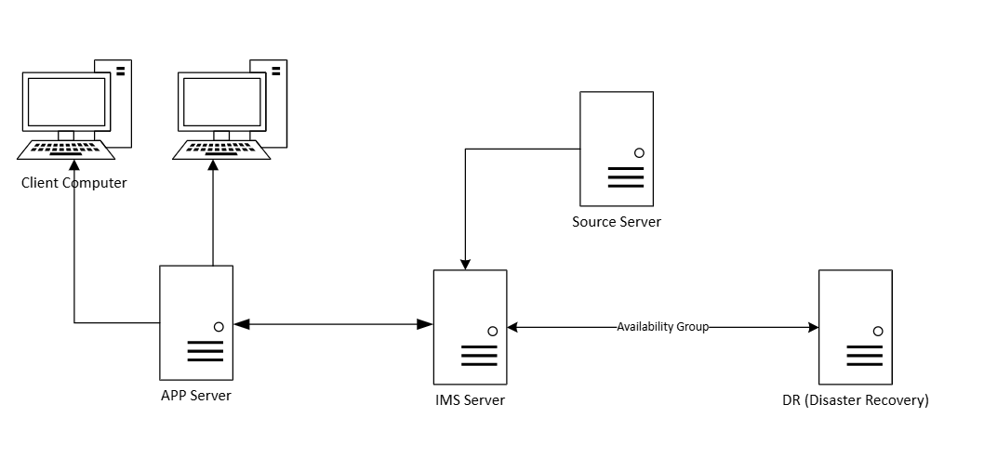
4.2 Component Responsibilities
Database Server
- MYSQL/Microsoft SQL Server
- Hosts:
  - Consolidated tables
  - Summary tables
  - Admin, parameter, and audit schemas
- Optimised for batch processing and read heavy workloads
- Maintains historical snapshots and Run ID based versioning
Database Tables & Requirements
- Separate database for overnight update – Sales, Product

- Application DB for all processes with below naming convention

  - Consolidated Tables:
    - Sales - Sales_TableName
    - Inventory - INV_TableName
    - Purchase - PUR_TableName
    - GRN - GRN_TableName
    - Pricing - PRC_TableName (Phase 3)
    - Product Management - PRD_TableName
    - Reporting - RPT_TableName
    - Admin - ADM_TableName
    - Slim4 - Slim_Article
    - Slim4 - Slim_Purchaseforecast
    - Edge - Location data
    - Edge - Product Attributes
    - Edge - Inventory
    - PIM - Mater Data & ADF
    - Cataloguing - Y/N (Mastercat & Alicat)
    - Datawarehouse - Lost Sales
    - Cataloguing - Car Parc

- Update tables from Autopart every overnight
    - Product
      - Alternatives
      - Supersessions
      - Supplier Part Details
      - Application Grouping (Bronze, Gold, Silver)?
    - Sales
      - IBT’s include & distinguishable
    - Purchase History
    - Open Purchase Orders (Lines & Headers)
    - Predel Details
    - GRNs
      - Including Special Orders – VOR’s DFS/NDC
    - Supplier
    - Stock – Overnight snapshots
      - To include Open PO, Predel Qty, Free Stock, Stock, Min, Max, Allocated Qty, Supplier, Cost etc…
    - Stock – Updated from live 4-5 times in a day (Both Single & Mid-Point)
    - Slim4 Article & Purchase Forecast Tables
    - MAM (Autopart) - Unsold Quotes

- Updated tables by Users on Application level
    - Updated by Inventory
      - Core table
      - Consignment Stock details
      - Parameter table (one table for all parameters)
      - Rule Tables
        - Profile Rule
        - Pullback Rule
4.3 Application
- ASP.NET Core Web API
- Acts as the control layer between UI, scheduler, and database
- Responsibilities:
  - Authentication and authorisation
  - Orchestration of stored procedure execution
  - Error handling and logging
4.4 Scheduler
- SQL Server Agent or enterprise scheduler (e.g. Lobster)
- Executes:
  - Overnight data refreshes
  - Profiling, pullback, replenishment, and levelling runs
- Prevents overlapping or conflicting executions
  - Stored procedures:
    - Inventory - S_INV_Name
    - Purchase - S_PUR_Name
    - Pricing - S_PRC_Name (Phase 3)
    - Product Management - S_PRD_Name
    - Reporting - S_RPT_Name
    - Admin - S_ADM_Name

4.5 Front end
- Browser based web application
- Provides:
  - Rule and parameter maintenance
  - Execution triggering and monitoring
  - Result review and reporting
- All data access is via the Application Server only

4.5.1 Front-End: Parameter Management
The front-end must allow users to configure time windows, min/max week rules, and business overrides prior to execution. All parameter changes must be logged per run.
4.5.2 Front-End: Execution Control
Users must be able to trigger manual runs, schedule automated runs, and perform preview runs. Each execution generates a unique Run ID with full metadata.
4.5.3 Front-End: Results & Review
The UI must provide a summary of dashboards, detailed data grids, audit views showing pattern and rule paths, and export functionality.
4.5.4 Front-End: Sequence Diagram – End-to-End Flow
The sequence below describes the full operational flow of STARS.
1. Planner configures run parameters in the UI.
2. Planner triggers execution, or a scheduler initiates a run.
3. Parameters are passed to the STARS engine.
4. Batch 1 executes: sales cleaning, supersession, and pattern classification.
5. Batch 2 executes: forecast generation.
6. Batch 3 executes: min/max calculation with overrides.
7. Batch 4 executes: profiling, valuation, and change reasoning.
8. Results are stored with the Run ID and exposed to the UI.
9. Planner reviews, filters, and exports results.
4.5.5 Front-End: Sample Screens
Landing Page
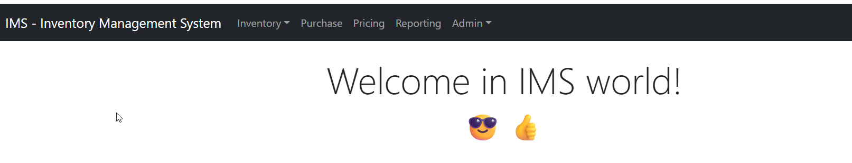
Menu
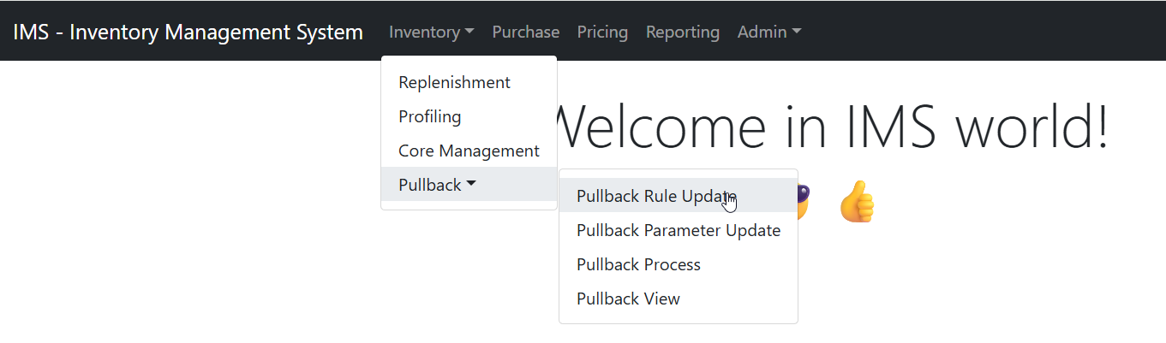
Rule Maintenance
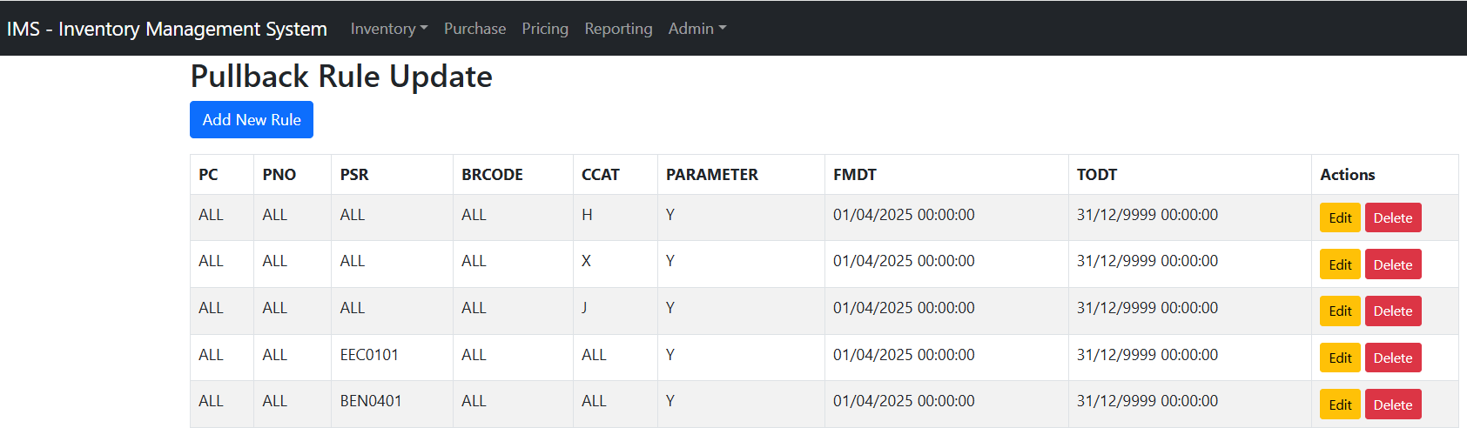
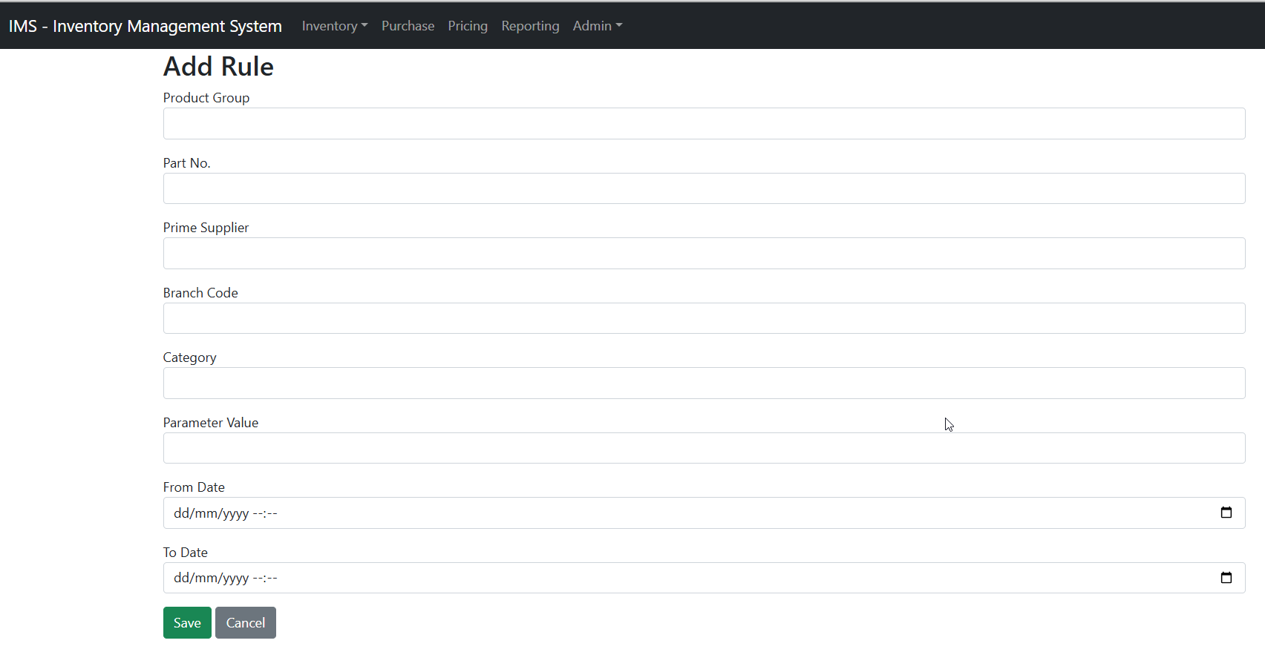
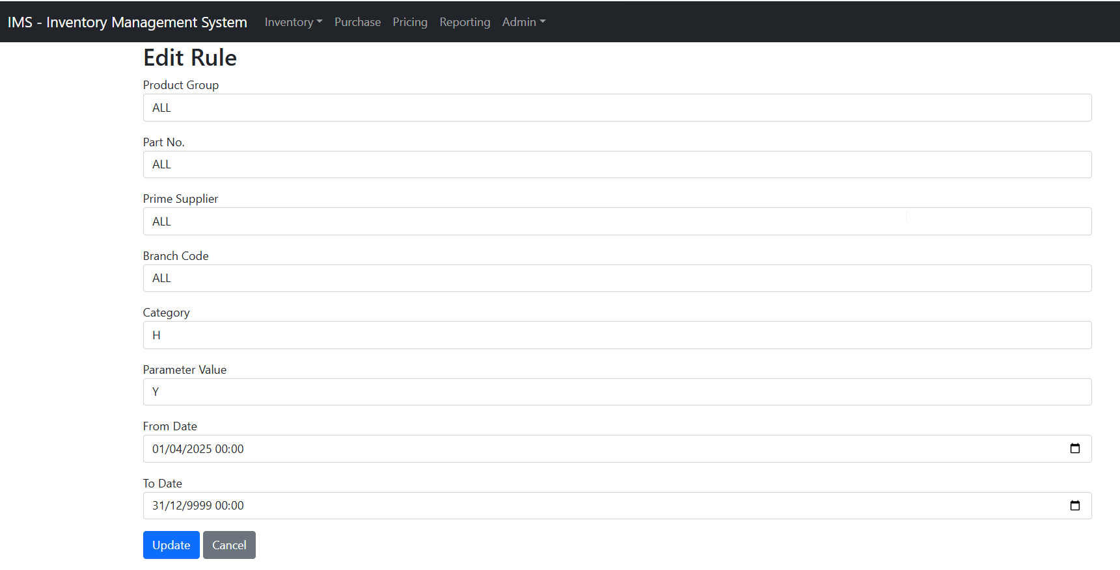
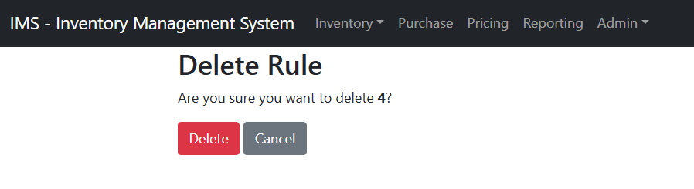
Parameter Maintenance
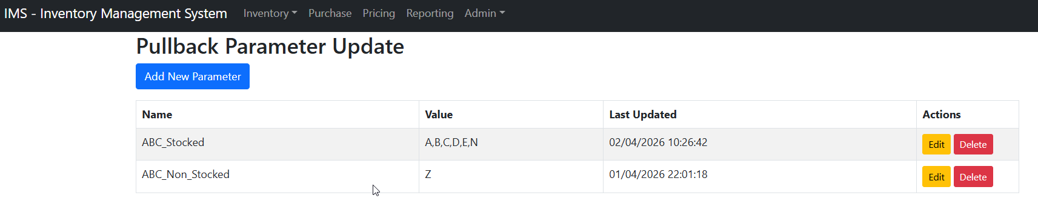

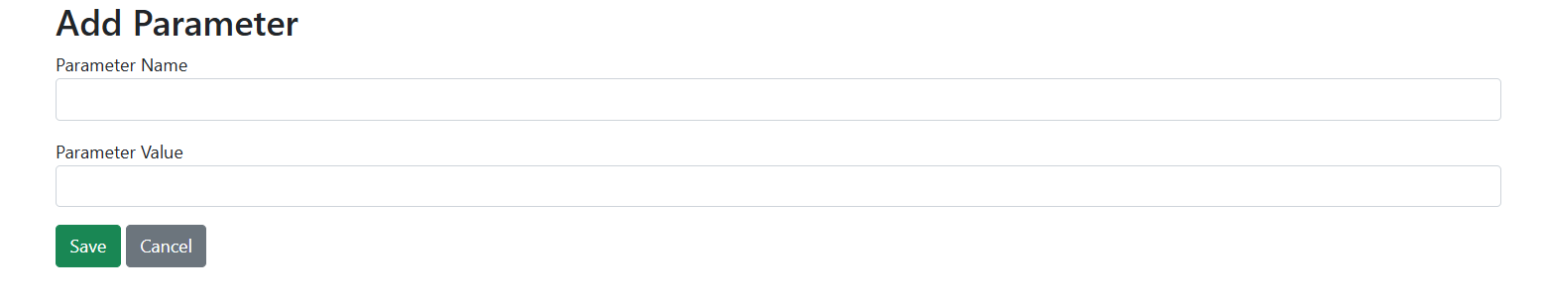
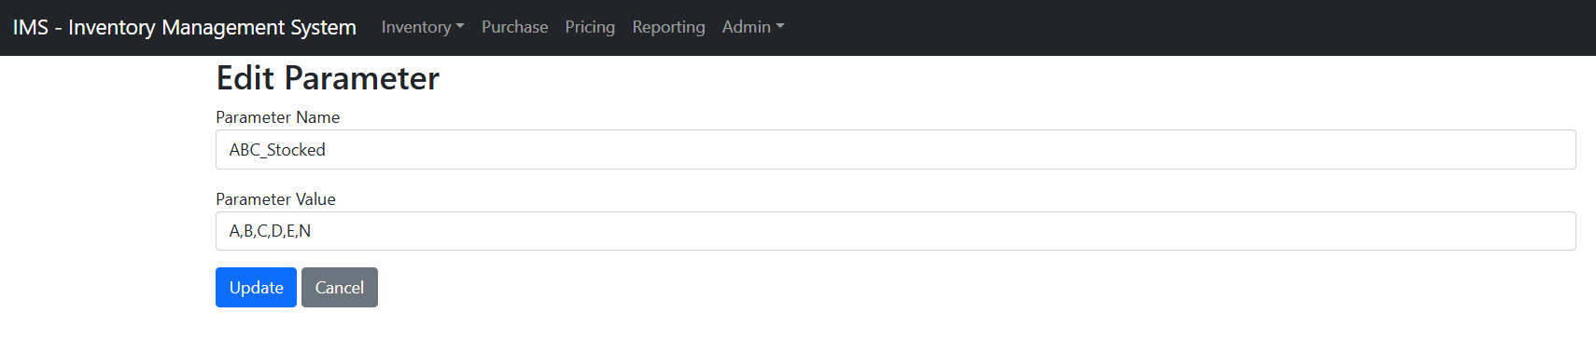
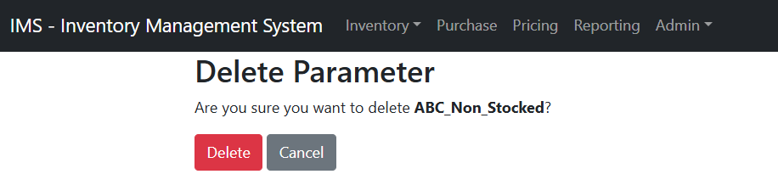
Pullback View
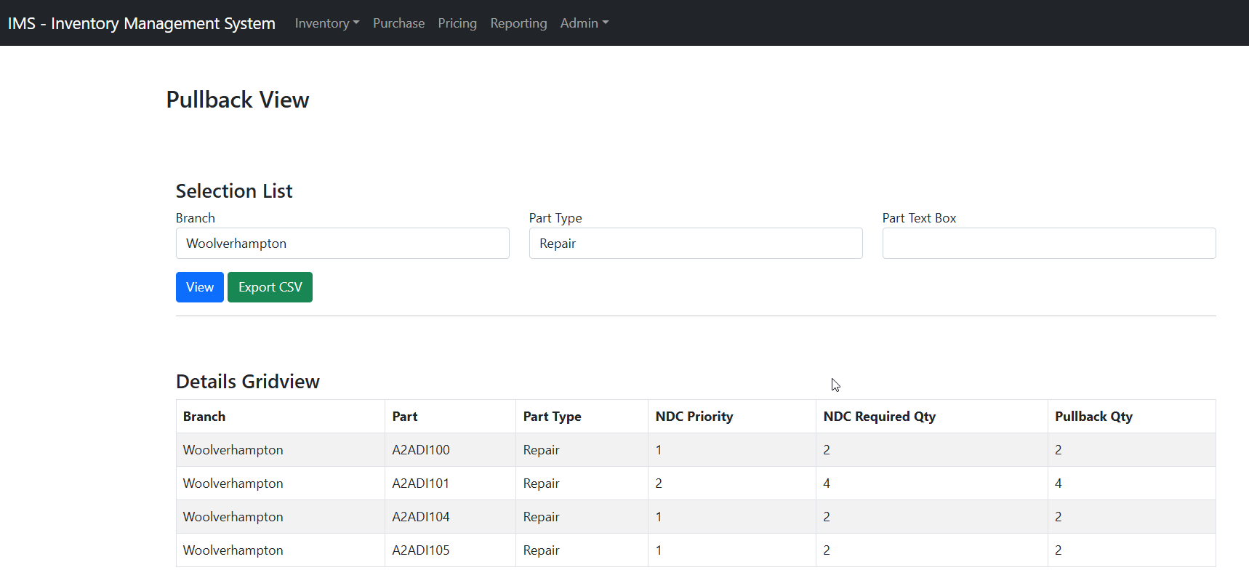
Pullback Process
Frontend not yet decided
5. Data Flow & Integration
5.1 ERP / Source Systems → IMS
IMS consumes the following data:
- Master data
- Sales history
- Purchase orders (open and historical)
- Inventory snapshots
5.2 IMS → ERP
IMS produces advisory outputs only:
- Replenishment order proposals
- Pullback recommendations
- Branch levelling suggestions
ERP systems retain full control over execution and posting.
6. Nonfunctional Requirements
6.1 Performance
- Overnight batch processing must complete within agreed batch windows
- Standard user queries must meet agreed response time SLAs
6.2 Security
- Role based access control
- No shared or generic accounts (SSO)
- Full audit trail of:
  - Parameter changes
  - Rule changes
  - Execution runs
- No direct database access from the frontend
6.3 Availability
- 24×7
6.4 Auditability
- Every execution uniquely identified by Run ID
- Historical outputs retained
- Full reproducibility of results
7. RACI & Ownership
- Business – Owns inventory rules, parameters, and functional sign-off
- IT – Owns platform, environments, security, and performance
- Data Team – Owns data integration and data quality

